**Examining Spatial Expansion and Stemming Strategies of Urban Shrinkage: Evidence from Detroit, USA**

Xiaoliang Meng1

Yichun Xie2,*

Andrew Crooks3

Junyi Wu1

Heather Khan Welsh2

Shi Zeng4

1 School of Remote Sensing and Information Engineering, Wuhan University, Wuhan, 430079, China

2 Department of Geography and Geology, Eastern Michigan University, Ypsilanti, MI 48197, USA

3 Department of Geography, University at Buffalo, Buffalo, NY., USA

4 Centre for Advanced Spatial Analysis, University College London, London W1T 4TJ, UK

* The corresponding author, [yxie@emich.edu](mailto:yxie@emich.edu) (0000-0002-2045-6406)

**Data and Code Explanation**

**All data (the following files) are accessible from**

1. gravitymap: The resulting map (ArcGIS Shape File) contains the calculated gravity scores.
2. SEM_T: The road network dataset that was used to calculate the gravity scores.

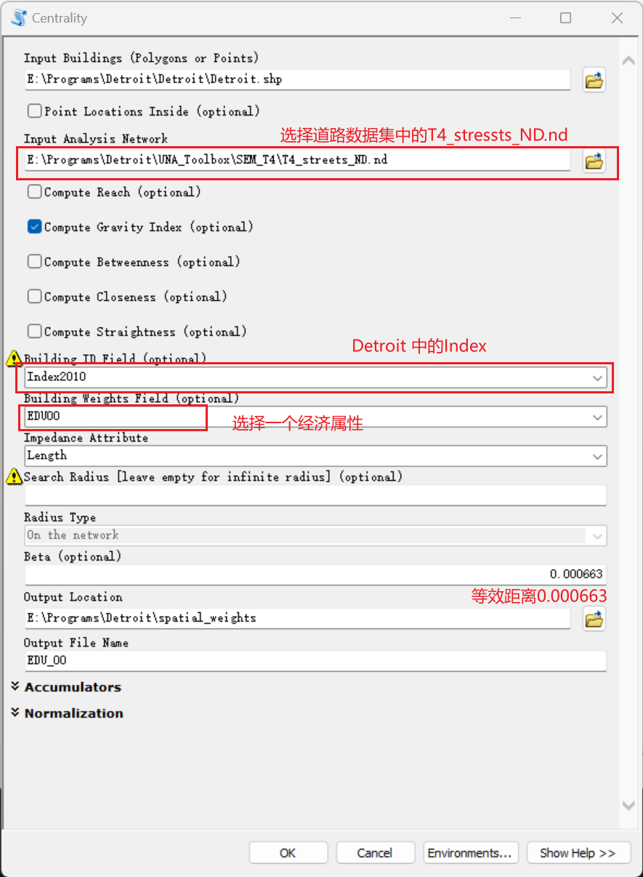

1. Tract_6_Fact_Seeds: the seeds (Shape File) for running Multivariate Clustering.

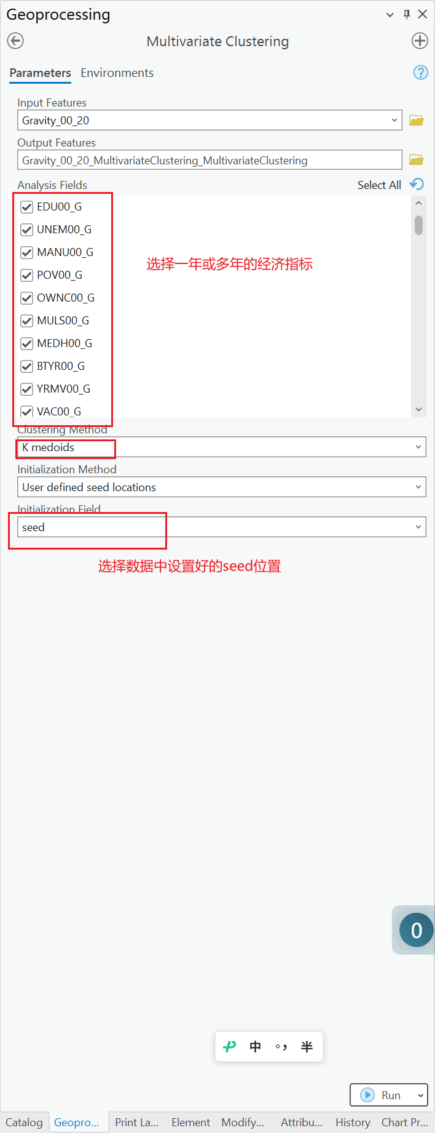

1. DetroitMap: the ArcGIS Shape File contains the merged socioeconomic and land use attributes (variables).
2. Detroit-Panel-Data.csv: the reorganized CSV file contains the merged socioeconomic and land use variables in the format required for running panel regression models.

1. Statacode-for-One-Cluster80.do: the Stata code for running Spatial Panel Regression Models for a single neighborhood adjacency matrix.
2. Statacode-for-Multiple-Clusters.do: the Stata code for running Spatial Panel Regression Models for multiple neighborhood adjacency matrices.
3. Detroit: The folder contains spatial weights (neighborhood adjacency matrices) and the Stata data file, panel_data.dta, which is the State format of the Detroit-Panel-Data.csv.